**VAN COMMUNITY COUNCIL**

**CYNGOR CYMUNED Y FAN**

**draft Minutes of the Remote Meeting**

**Wednesday 18th May 2022**

**Present:**

By Video: Cllr Sheila Newbury, Cllr Sheila Jones, Vice Cllr Anne Broughton-Pettit, Cllr John Pettit, Cllr Lynne Hughes, Cllr Matthew Ferris, Cllr Jeff Grenfell, Chair Cllr Elaine Forehead, Cllr Christine Forehead

By Phone: None

**Apologies:** None

**In Attendance:** Michelle Moore (Clerk)

**1. Police & Community Safety**

Reviewed the police report provided by CSO Sarah Barbour

**Resolved:** Cllr Matthew Ferris to contact the Fire Service to invite them as guest speaker in a future meeting

2. Chair welcomed all new members

**3. Declarations of Interest**

NONE

**4. Minutes**

The minutes of the remote ORDINARY FULL COUNCIL meeting held on 17th March 2022 were agreed as an accurate record.

**5. Financial matters**

5.1 Bank Reconciliation for March, Bank Statements for March

Received and agreed

5.2 Bank Reconciliation for April, Bank Statements for April

Received and agreed

5.3 Payments for March

Received and agreed

5.4 Payments for April

Received and agreed

5.5 End of year accounts

Received and agreed

**6. Audit Year Ended 31st March 2022**

6.1 Received Internal Auditors Report

6.2 Received Bank Reconciliation

6.3 Received and approved Annual Return, arrangements made for Chair to sign and certify

**7. Annual Report**

Received

**8. Clerks Report**

Received

**RESOLVED:** Clerk to purchase two more Licenses @ £78 each for ‘vancc email accounts’

**RESOLVED:** Clerk to renew insurance with Arthur J Gallagher Community Schemes, Insurance Policy @ £716.81

For the period of June 1st 2022 to May 31st 2023

**9. Community Engagement**

1.Cllr Sheila Jones updated the council on the participation of Van Community Centre and the delivery of food parcels and invited the new councillors to get involved

**Resolved**: Clerk to forward details and information on The Parish Trust to all councillors, so that they can make referrals

2.Raised beds at Van Community Centre have been prepared for planting and volunteer Alison Godfrey has suggested planting needs to take place this week

Cllr Sheila Jones will try and delay this until next Wednesday, so the pupils of St James school can be involved

3**.Agreed** that Cllr Sheila Jones should go ahead and contact Rachel Carter @ OVW, and submit an application for funding for the development of the Land at the End of Van Terrace

4. Jubilee BBQ event organised by Parent Network and Bridgingtogether

Funding for £424 was requested

Van Community Centre have given permission for the centre and the use of the carpark free of charge

Councillors have been invited so that they can introduce themselves to the community

**No clear outcome**

Noted

Cllr Jeff Grenfell does not want the council to use its resources for Jubilee celebrations

Noted

Cllr Lynne Hughes does not want the council to use its resources for Jubilee celebrations and no official request for financial assistance has been made.

Noted

Cllr John Pettit says we should be supporting these events

**Unanimously agreed** that the chairs allowance £500 could be donated to support the event

**Resolved:** Clerk and chair to discuss putting this in place immediately

5. Tennis lessons

Note

Declaration of Interest

Chair Elaine Forehead has relatives in St Helens School

**Agreed** to continue with the present structure in place to deliver the scheme to pupils at St James, and for the council to continue to improve and develop the project so that it may be open to a wider spectrum of residents in the future

A decision on the amount of funding will be dependent on the response and number of applicants.

**Resolved**: Clerk to contact St James and move forward with the scheme

**10. Planning Applications**

NONE

**11. Items for next Agenda**

1. Revised budget

2. Update on the Tennis Lessons

3. Revisit from AGM Chairs Allowance- for a discussion on Cllr Allowances

4. Revisit from the AGM-To consider whether any committees be set up on a standing or ad hoc basis and to appoint members if necessary

**NOTED**

A request by Cllr Lynne Hughes for better etiquette to be adopted in future meetings

**13. Date of next meeting**

Thursday June 16th, 2022

Chair Elaine Forehead

Van Community Council

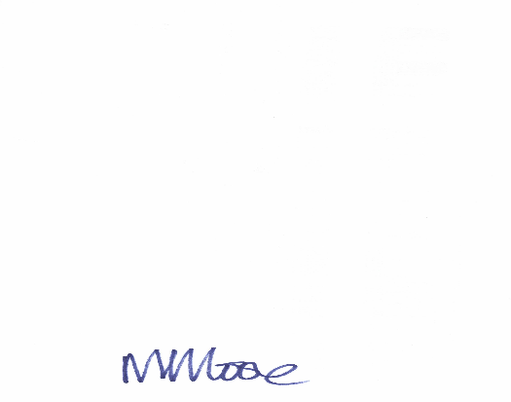 Clerk